Administrator’s User Manual For OrangeHRM Booking

Contents
Audience 3
Support Environment 3
Booking Module 3
How it works 4
Installation 4
Configuration 6
Settings 7
Check License 7
Bookable Resources 8
Adding a Bookable Resource 8
Modifying a Bookable Resource 9
Searching a Bookable Resource 10
Bookings 12
Month view 12
Week view 13
Custom Period 13

Audience

This document is intended as a complete guide for using the Booking Module in OrangeHRM 4.0. This document is specially designed for non-developers; developers may find the document a useful point of reference.
By reading this guide, you will learn how to use Booking Module for OrangeHRM through the elements of the graphical user interface and what's behind some of the features of the module.

Support Environment

The Booking Module has the same requirements as OrangeHRM 4.0. For further details about the requirements of OrangeHRM 4.0 please check the web site of OrangeHRM.

Booking Module

The Booking Module is a powerful tool providing administrators the ability to manage the booking of a resource (employee) for a project during a period of time. The administrator can assign which employees can be booked, and checking the projects they are or were assigned to work on.
This module operates with a license key, which should have been sent to you along with the download link of this module. Also this module registers the domain of your OrangeHRM site, so keep in mind there is a maximum number of domains you can register with your license key. Once you reached this limit, you CAN NOT use this module in more sites.
This module has a page for configuring the break times of the company, a page for checking the license status, a section for managing the employees that can be booked and the bookings of your company.

How it works

A booking is a combination of a employee who has been assigned to a customer’s project for a period of time. When adding or editing a booking, the module checks the booking duration, and splits the selected period into several bookings using the company’s work week, while skipping the holy days and non-working days.
For doing so, this module combines functionalities of several modules of OrangeHRM. It uses the Employee functionality form the PIM Module, Leave Period, Work Days and Holidays from the Leave Module and Customers and Projects from Time Module.
For example, if a employee was assigned to a project from December 15 to January 24, and company set the Christmas and New Year days as holy days, the module would create bookings for every work week between those dates, and would skip the Christmas and New Year days.

Installation

In order to install this module, you need to uncompress the zip file in the root directory with your OrangeHRM installation. It’s recommended you do a backup of your current installation. Once the backup is done, you can proceed with the installation. This module uses a very easy to use interface for installing the new module.
First, open a browser and navigate to your OrangeHRM site. Then go to url for installing the module, which is your [domain]/booking_install.php, ie if your site has the name example.org, the link for installing would be example.org/booking_install.php. Once you have navigated to the install GUI, you will see the following form.

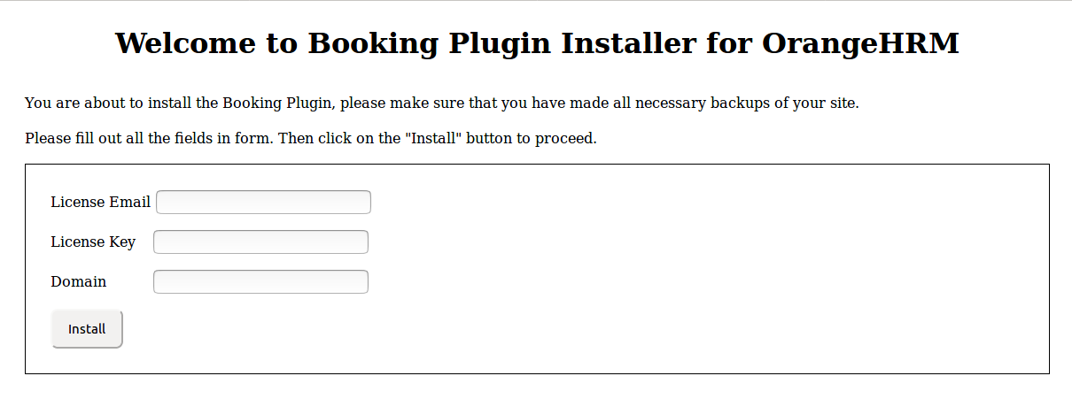

Enter the email you used for getting the plugin, the license key you got with the download link of the module and your site domain. Usually the domain is auto detected, just make sure the domain is correct.
Once you have filled out the form, click on the install button. Then you will see a page with the installation logs.

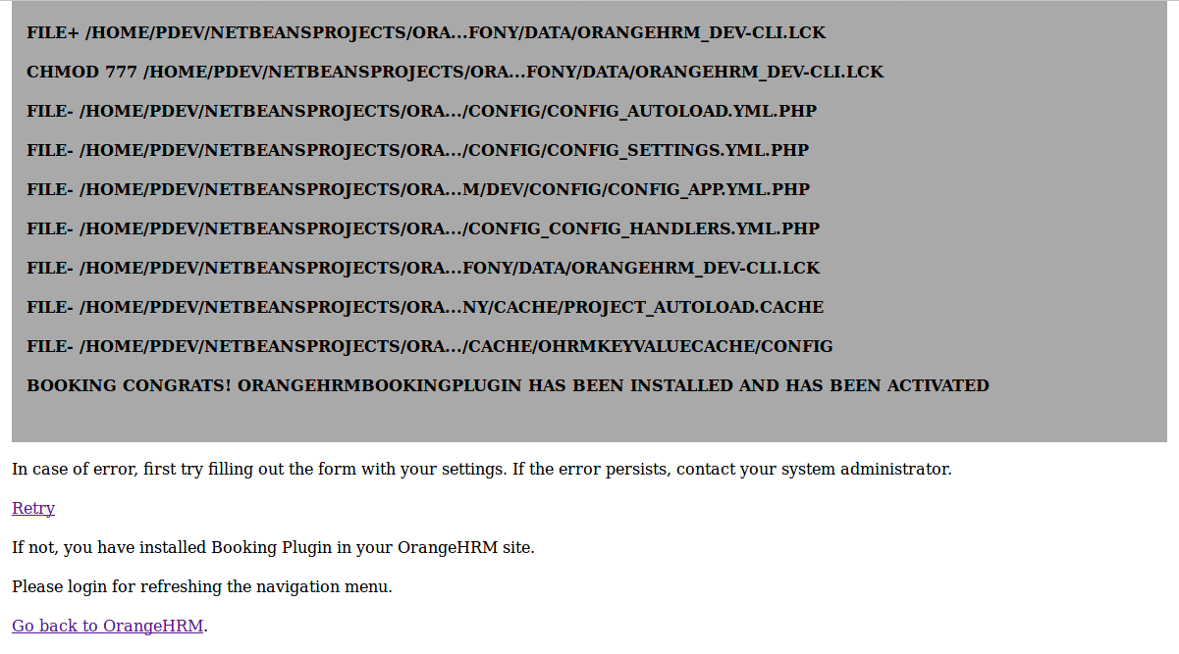
Please check the logs, in case of errors make sure you entered the right values for the email, license key and domain. If the entered data was right, you have installed the module, and there is a new menu item in the navigation menu, which will be visible after you login again in the application.

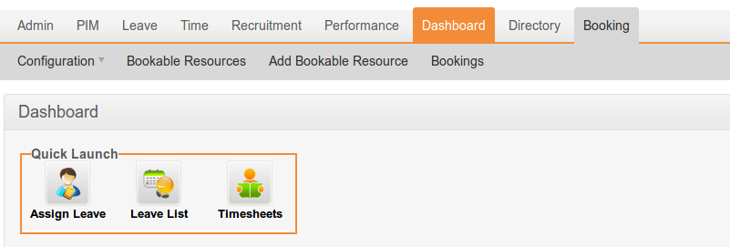

If the errors persist, copy the logs and contact your system administrator.

Configuration

The module itself uses the work week, work shifts and holy days configurations that are set in your OrangeHRM site. In case those settings are not set previously, the module will use the default values of those settings.

This module has 2 items under the configuration sub menu: Settings and License.

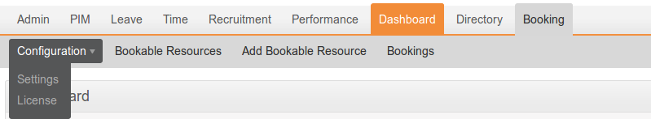

Settings
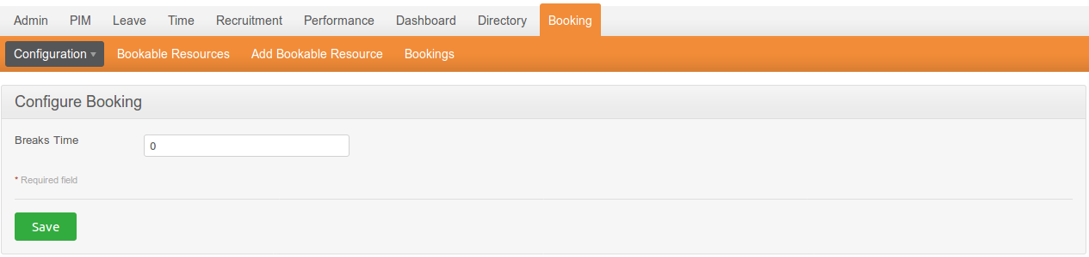
In this page you can configure how much time of the work day is assigned to breaks. This value will be used for calculating the total duration of a booking. The default value is 0 (zero) hours.

Check License
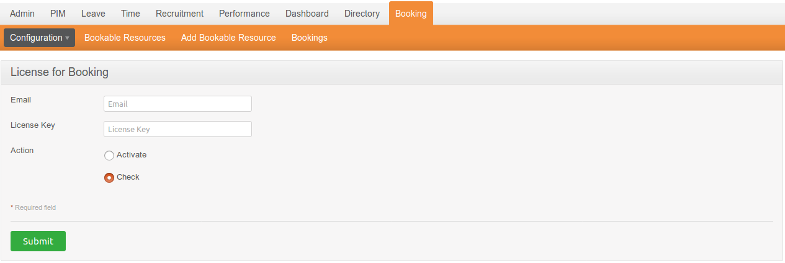
In this page you can check the status of the module’s license.
If by any chance the license was not activated, in this page you can activate it. For doing so, please enter the email you used for getting the plugin, the license key you got with the download link of the module and your site domain. Then choose the option ‘Activate’ and click on the ‘Submit’ button.

Bookable Resources

In this section you can manage which employees can be booked.
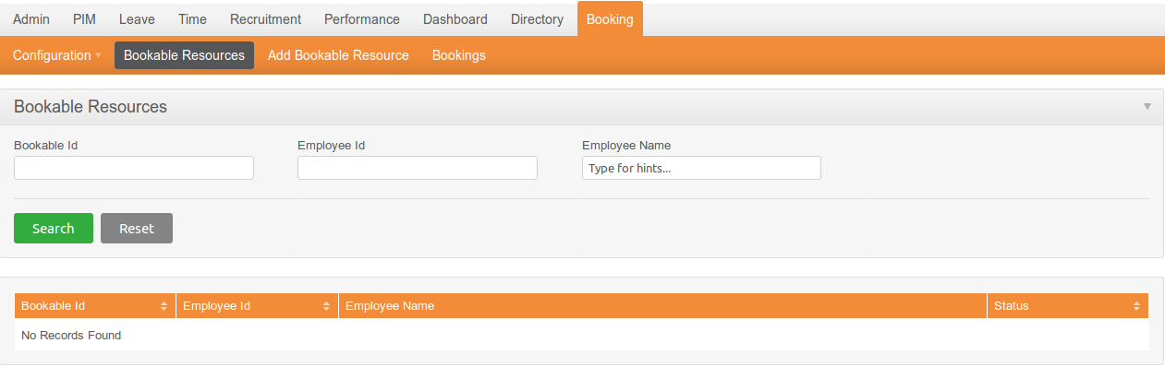
This page initially shows the full list of bookable resources set in the module. This list has links to employee profile and bookable profile. Also this list shows the status of the bookable resources, which means if a resource can be booked or not. An ‘active’ status means the resource can be assigned to a project, and you can modify any booking of said resource.
An ‘inactive’ status means the resource will not be assigned to a project and his/her bookings can not modified, but it doesn’t remove the resource from the previously assigned projects. In other words, any booking of this resource is read-only, and you can not add this resource to new projects.

Adding a Bookable Resource

For adding a bookable resource click on the menu ‘Add Bookable Resource’, then you will see the following form.

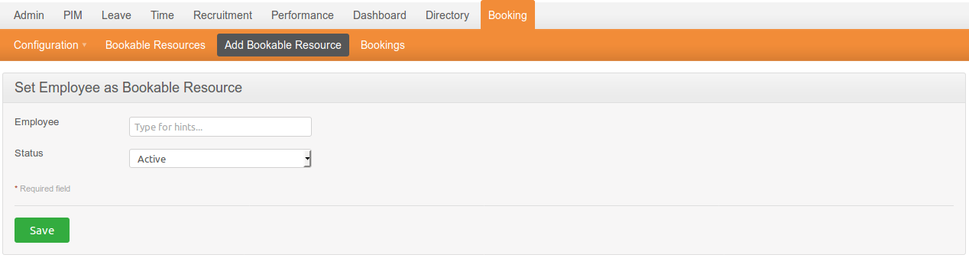
In the employee field you can type a name for searching an employee, then you select the desired employee.

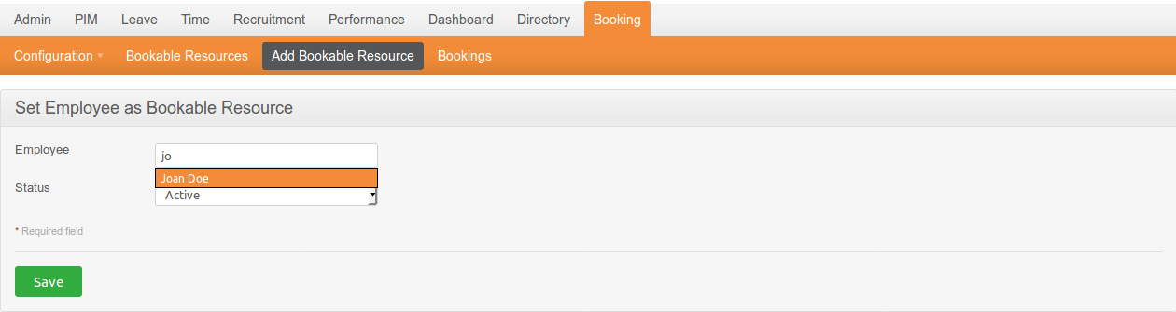
Once you have selected the employee, you need to set if the resource is active or inactive. After saving the new bookable resource, you will be redirected to bookable resources page.

Modifying a Bookable Resource

For modifying a bookable resource click on the bookable Id link of the resource. You will see the next page.
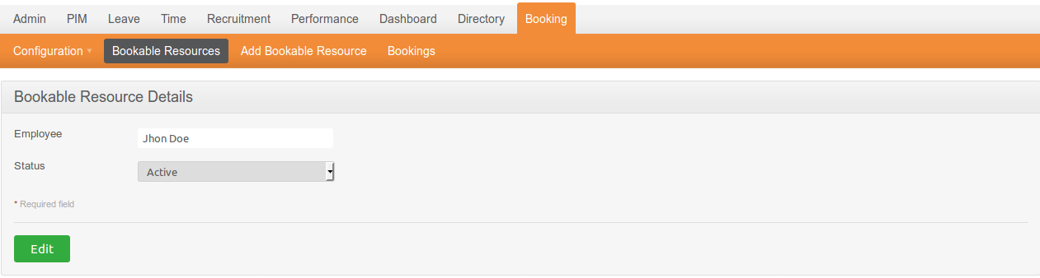
In this page you see the current status of the resource, for changing it click on the ‘Edit’ button. Then the form will be enabled for editing.

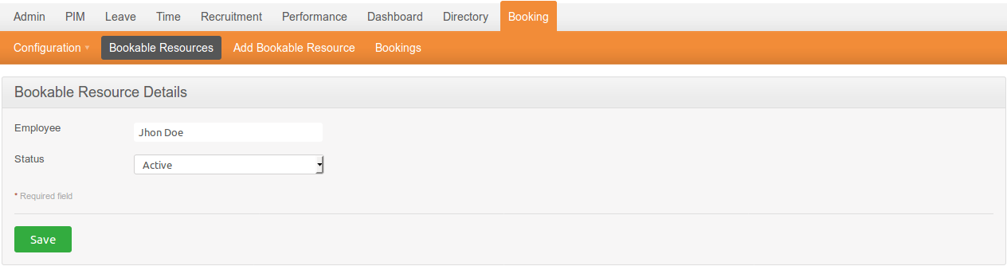
Then change the status and click on ‘Save’ for updating the resource status.

Searching a Bookable Resource

In the search bar there is a field for searching by bookable id, employee id and employee name. This is very helpful in case you have a large list of employees in the company.

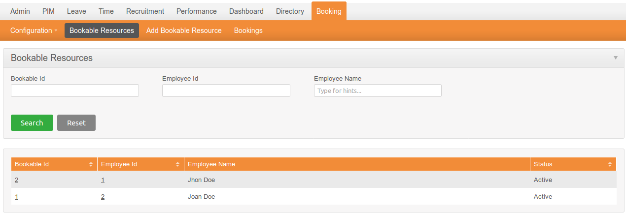
Fill out any of those fields, then click on ‘Search’ button.

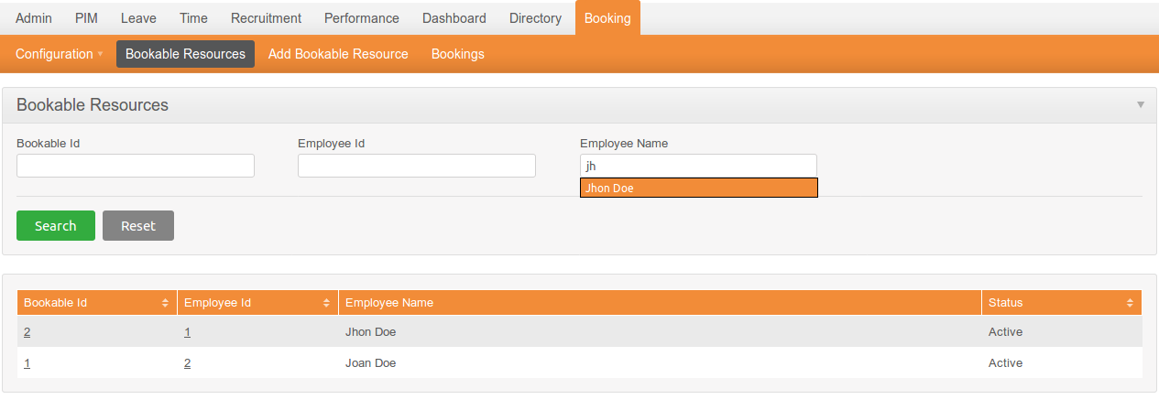
Finally you will see the filtered list of bookable resources.
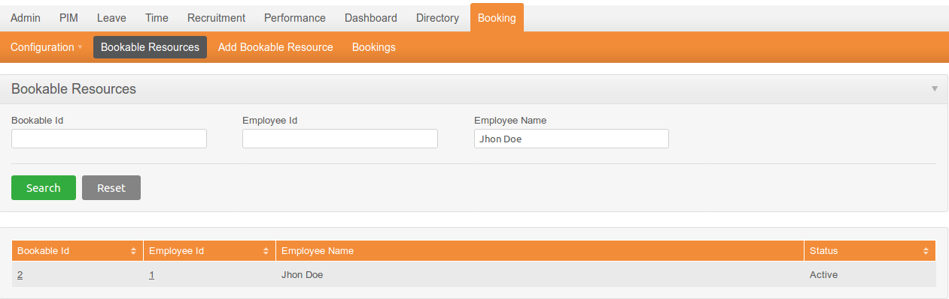
For clearing the filter criteria just click on ‘Reset’ button and it show the full list of bookable resources.

Bookings

In this page you will see the bookable resources and a calendar with bookings within the period of time. The calendar can show a full month, a week or a custom period of time.

Month view

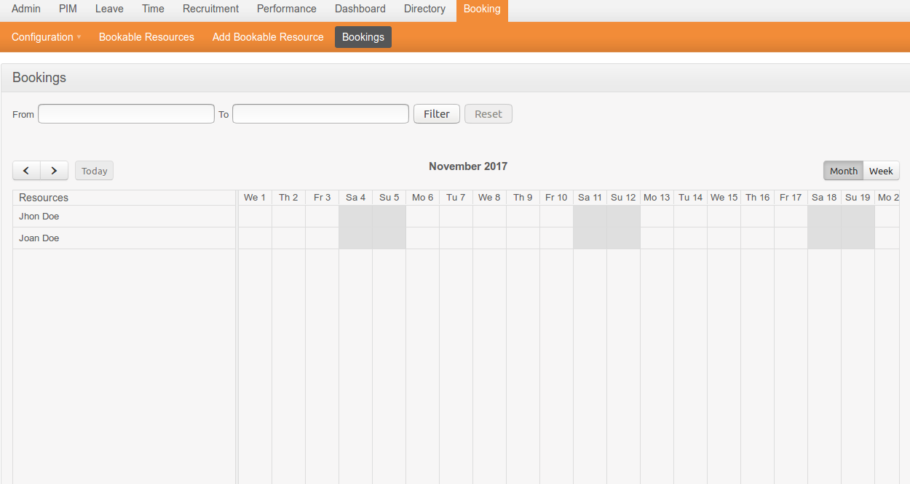

Week view

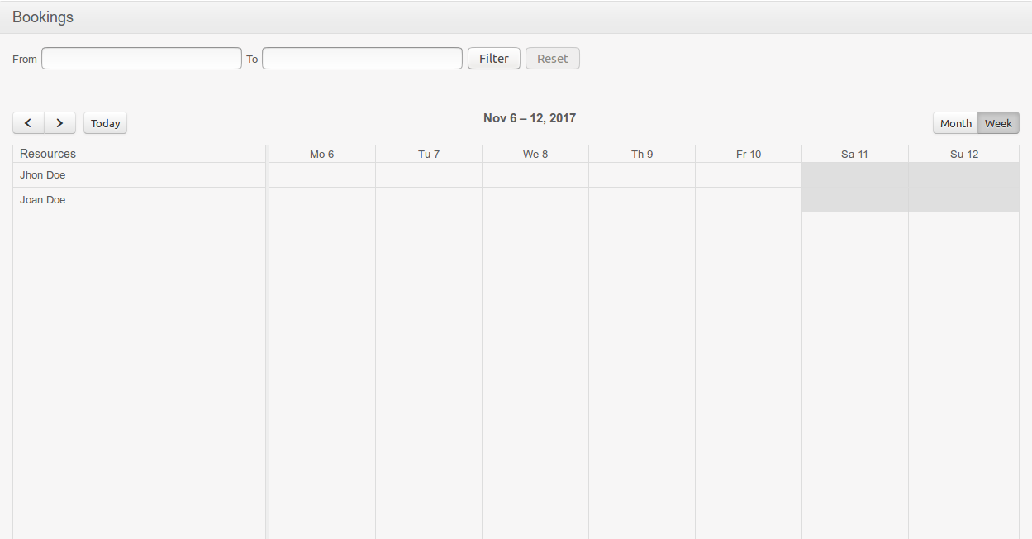

Custom Period
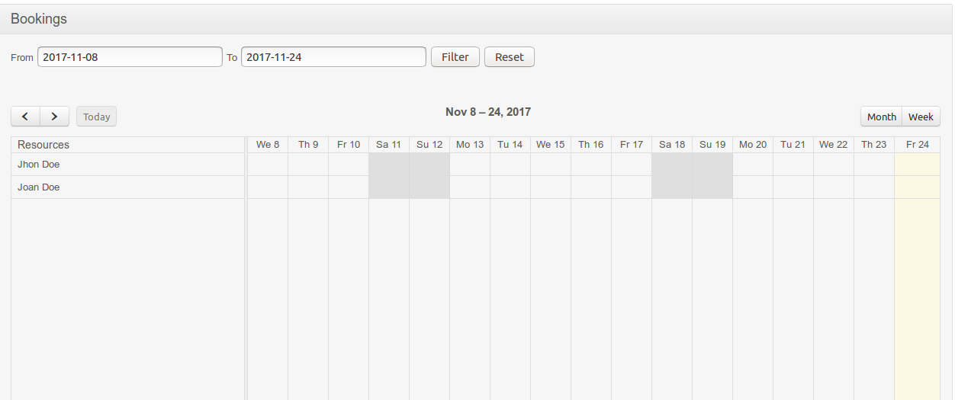

In those views the non-working days of a resource will be gray colored. In case of holidays, they will be also gray colored, but the coloring will cover the whole day, and they will show a tooltip with the holiday’s name.

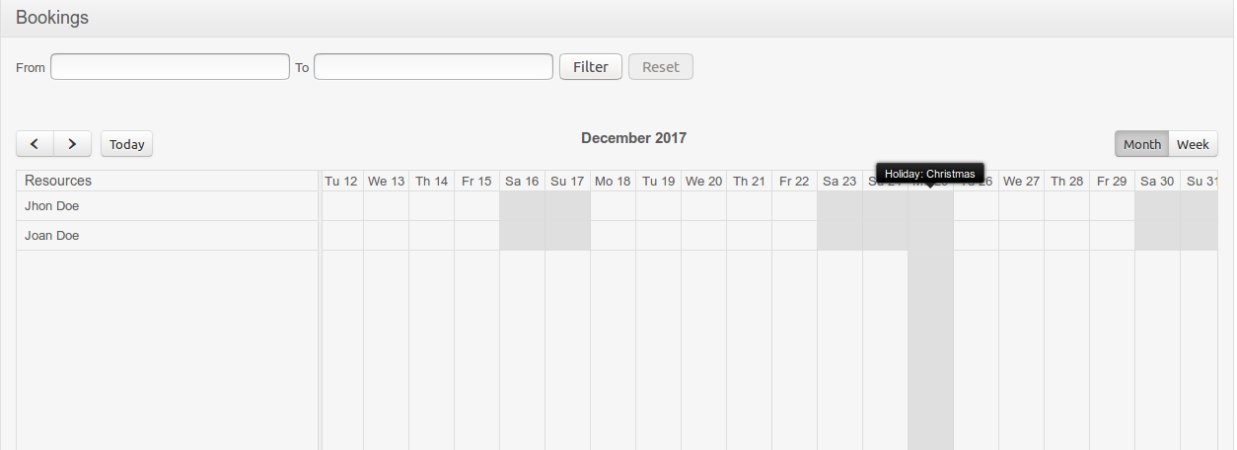

By default the Booking Module uses monday as the first working day of the week, while saturday and sunday are non-working days. This depends on the configuration of the company’s working week, first working day and the work shift of each employee.

Adding a Booking

For adding a booking to a resource you can click on any day or by selecting a range of days in the same line of desired resource.
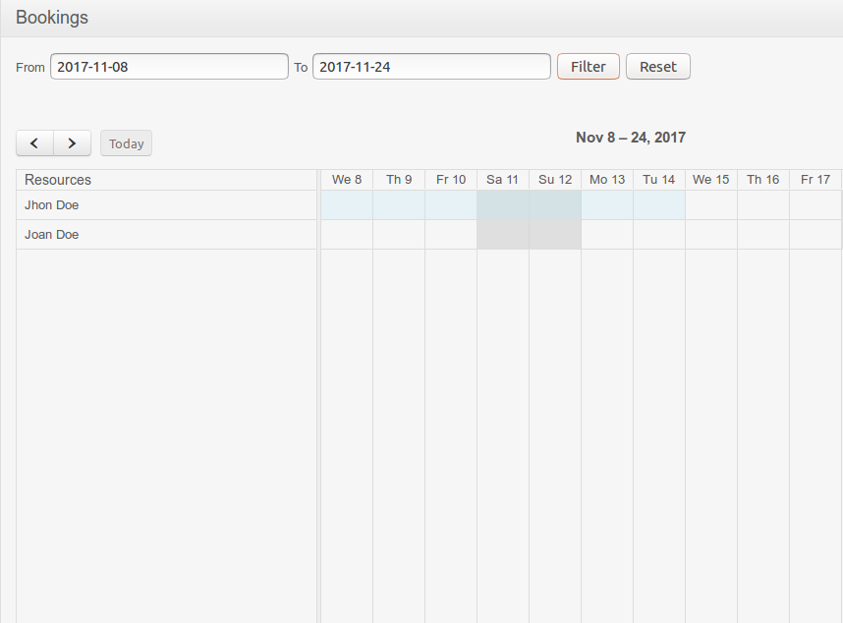

Then a popup will appear with the following form.
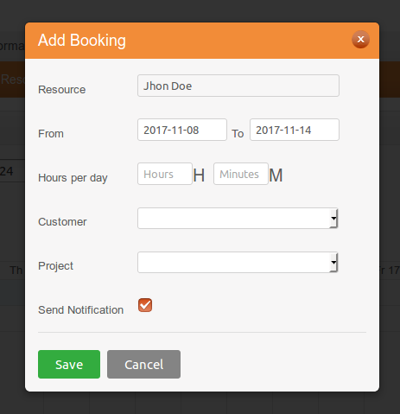

This form will show you the chosen resource along with selected day(s). You can change the date range according to your needs. Fill out the booking duration per day. Select a customer and then you can select any project of selected customer. The option for sending a notification to resource is optional, and can be unchecked.
Finally click on ‘Save’ button. The calendar will refresh and will show bookings within the current period of time. Keep in mind that non-working days will be skip.

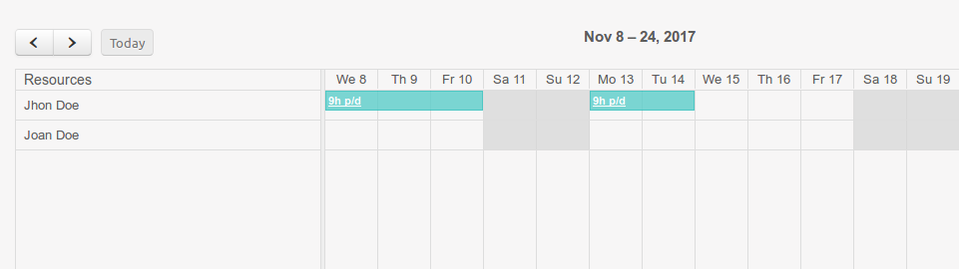

If can see some booking details by hovering over it.

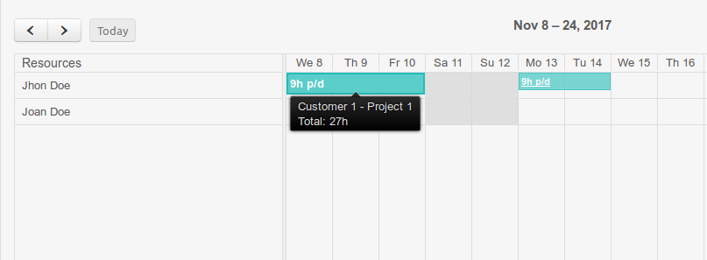

Adding a Booking for Non-Working Days And/Or Holidays

The Booking Module will skip non-business days and holidays out of calendar, but it’s possible to have bookings in non-working days, with the only exception is that booking only longs for a day. If you need to add bookings to more than 1 day you will have to do it one by one.
For adding a booking in a non-working day it just click over it. The system will show a confirmation message, which will vary depending on if clicked day is a non-business day or a holiday.

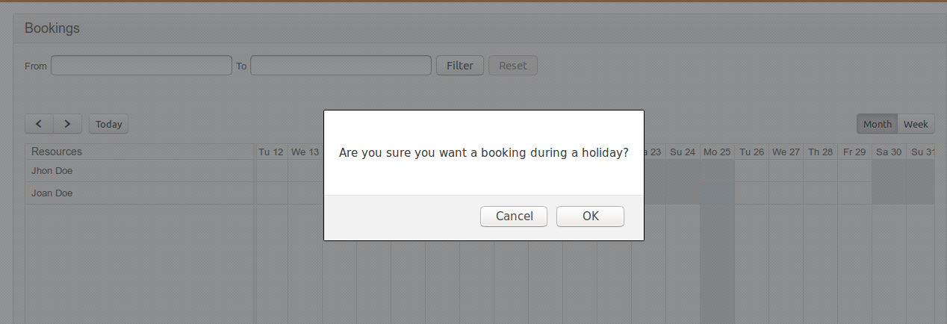

Once you have confirmed you want to add a booking, the popup will appear with the form for entering the booking details.

